DOCTOR: Brandon Galbraith D.C. or Dr. Matthew Schwieterman
DATE OF VISIT ___/___/20___ Patient____________________________________________ Age_________________
_____INITIAL EXAMINATION _____ RE-EVALUATION _____ NEW CONDITION
*It must be noted that if this is a new complaint from what you have been treated for in the past or currently, a re-exam may be necessary. A re-exam will also be necessary to provide care if your treatment plan has finished or you have not been in the office in over 9 months.*
1

Please give first date you noticed symptoms _____________________________________________________
What are your major complaints?
1.____________________________________________________
2.____________________________________________________
3.____________________________________________________
4.____________________________________________________
5.____________________________________________________

Place an “X” on the drawings of the body wherever you have pain

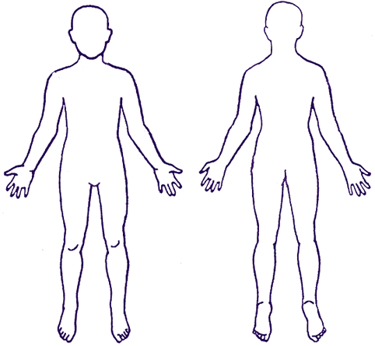
Front

Back

RATE YOUR PAIN
PAIN SCALE: Please circle the number that best describes your overall pain:
0 1 2 3 4 5 6 7 8 9 10 10+

PATIENT OR AUTHORIZED REPRESENTATIVE SIGNATURE DATE
_______________________________________________________ _________________
Left
Right
Right
Left
Height:_________
Weight:_________
A=Ache
B=Burning
ST=Stabbing
SP=Spasm
N=Numbness
P=Pins and Needles
T=Throbbing

(Example: XST between your shoulders mean you have stabbing pain between your shoulders)

Have symptoms Increased Decreased Same since start
Frequency: Circle your answer
Constant 100%-75%
Frequent 75%-50%
Intermittent 50%-25%
Occasional 25%- 1%
Discomfort decreases with: ______________________________
Discomfort increases with: _____________________________

Is this condition realted to an auto accident? YES NO Date of Accident:________________
Are your present problems due to an injury? YES NO Date of the injury:________________
Was the injury? Auto Accident Peronsal Injury Other (explain):________________________
___________________________________________________________________________________
Do you have any current work restrictions due to this condition? YES NO
Do you suffer from any condition other than that for which you are now consulting us? YES NO
_________________________________________________________________________________
List any tests, studies or medications received for THIS condition:
Tests/Studies: ___________________________________________________________________________________________________________________________________________________________________________________________________________
Medications being taken for current condition: ___________________________________________________________________________________________________________________________________________________________________________________________________________
Have you ever been to a chiropractor before?
YES NO CLINIC/DOCTOR:__________________________________________________________________
Pregnant? YES NO
Do you have a pacemaker? YES NO
Have you ever had any surgeries? _____________________________________________________________________________________________________________________________________________________________________________________________________________________________________________________________________________________________________________________
Have you ever had X-rays taken? (IF YES PLEASE STATE WHERE THEY WERE TAKEN AND WHY THEY WERE TAKEN) _____________________________________________________________________________________________________________________________________________________________________________________________________________________________________________________________________________________________________________________
Have you been diagnosed with: (Please circle)
Diabetes Type:___________ High Blood Pressure Arthritis Degenerative Disc Disease High Cholesterol
Disc Bulge Scoliosis Anemia Polio Cancer Type: ______________
HABITS:
Current Every Day Smoker Current Some Day Smoker
Former Smoker Never Smoker
Drinking Alcohol: (Cups/day): _____ Coffee Cups/Day: _______
Soft Drink Bottles or Cans/Day: _____ Water Cups/Day: _______

Chiropractic Case History/Patient Information

Date:__________________ Doctor: Dr. Brandon Galbraith OR Dr. Matthew Schwieterman

Name:__________________________ Social Security #__________________Home Phone: _______________
Address:____________________________________City:___________________ State:______ Zip:___________
E-mail address:____________________________ Cell Phone:__________________
Age:_______ Birth Date:___________ Race:______ Gender: M or F Marital: M S W D
Occupation:_________________________ Employer:________________________________________________
Employer's Address:__________________________________ Phone:__________________________________ Spouse:___________________ Occupation:________________ Employer:___________ Phone:______________
How many children?____________Names and Ages of Children:________________________________________
___________________________________________________________________________________________
Name of Nearest Relative:________________________ Address:______________________Phone:___________
How were you referred to our office?______________________________________________________________
Family Medical Doctor:_________________________________________________________________________
When doctors work together it benefits you. May we have your permission to update your medical doctor regarding your care at this office?___________
Please check any and all insurance coverage that may be applicable in this case:

❐ Major Medical  Worker's Compensation  Medicaid  Medicare  Auto Accident
❐ Medical Savings Account & Flex Plans  Other

Name of Primary Insurance Company:______________________________________________________________________

Policy holder:________________________ Birthdate of policy holder: __________________ Relation:__________________

Name of Secondary Insurance Company (if any):___________________________________________________

AUTHORIZATION AND RELEASE: I authorize payment of insurance benefits directly to the chiropractor or chiropractic office. I authorize the doctor to release all information necessary to communicate with personal physicians and other healthcare providers and payers and to secure the payment of benefits. I understand that I am responsible for all costs of chiropractic care, regardless of insurance coverage. I also understand that if I suspend or terminate my schedule of care as determined by my treating doctor, any fees for professional services will be immediately due and payable.

The patient understands and agrees to allow this chiropractic office to use their Patient Health Information for the purpose of treatment, payment, healthcare operations, and coordination of care. We want you to know how your Patient Health Information is going to be used in this office and your rights concerning those records. If you would like to have a more detailed account of our policies and procedures concerning the privacy of your Patient Health Information we encourage you to read the HIPAA NOTICE that is available to you at the front desk before signing this consent. The following person(s) have my permission to receive my personal health information:

Patient's Signature:_____________________________________________________ Date:________________
Guardian's Signature Authorizing Care:_____________________________________ Date:________________

FAMILY HISTORY (Who: Grandparents, Parents, Siblings)
Cancer (What Type)
_______________________________________________________________________________________________________Diabetes
_______________________________________________________________________________________________________

EXERCISE YES NO
If yes please explain (Type and how frequent)__________________________________________________________________
______________________________________________________________________________________________________________________________________________________________________________________________________________

MEDICATIONS
Are you taking any medication (prescription or over-the-counter)? Yes No
If Yes, please indicate the following:
Medication: _____________________________ Medication: ______________________________
Route: Oral Route: Oral
Intravenous Intravenous
Other: ____________________ Other: ____________________
Frequency: __________________________ Frequency: _______________________________
Began Use: __________________________ Began Use: _______________________________
Discontinued Use: ____________________ Discontinued Use: _________________________

Medication: _____________________________ Medication: ______________________________
Route: Oral Route: Oral
Intravenous Intravenous
Other: ____________________ Other: ____________________
Frequency: __________________________ Frequency: _______________________________
Began Use: __________________________ Began Use: _______________________________
Discontinued Use: ____________________ Discontinued Use: _________________________
_______ _______
Have you taken any medications in the past? Yes No If yes, which ones?:
Do you have allergies to medication? Yes No
If Yes, please indicate the following:
Allergy: _______________________________ Allergy: _______________________________
Reaction: ______________________________ Reaction: ______________________________
Start Date: _____________________________ Start Date: _____________________________
End Date: ______________________________ End Date: _____________________________

Allergy: _______________________________ Allergy: _______________________________
Reaction: ______________________________ Reaction: ______________________________
Start Date: _____________________________ Start Date: _____________________________
End Date: ______________________________ End Date: _____________________________

Please check the box for each current or past symptom listed.
EYE/EAR
GENERAL SYMPTOMS GASTRO-INTESTINAL NOSE/THROAT RESPIRATORY
❑ Allergy(What) ____  Belching or Gas  Asthma  Chest Pain
________________  Colon Trouble  Deafness  Chronic Cough
❑ Bronchitis  Constipation  Earache  Difficulty Breathing
❑ Chills (Constant)  Diarrhea  Ear Discharge  Spitting Blood
❑ Convulsions  Gall Bladder Trouble  Ear Noises  Spitting Phlegm
❑ Dizziness  Hemorrhoids (piles)  Thyroid Problems
❑ Fainting  Jaundice  Frequent Colds GENITO-URINARY
❑ Fatigue  Liver Trouble  Hay Fever  Bed Wetting
❑ Headache  Nausea  Nasal Obstruction  Blood in Urine
❑ Loss of Sleep  Stomach Pain  Nose Bleeds  Frequent Urination
❑ Loss of Weight  Vomiting  Pain in Eyes  Inability to Control
❑ Nervousness  Vomiting Blood  Poor Vision   Urine
❑ Night Sweats  Heart Burn  Blurred Vision  Kidney Infection
❑ Numbness or Pain  Bloody Stools  Sinusitis  Kidney Stones
in arms/legs/hands  Acid Reflux  Sore Throats  Painful Urination
❑ Wheezing  Irritable Bowel  Tonsillitis  Prostate Trouble
Muscles & Joints Cardio-Vascular Skin or Allergies For Females Only
❑ Backache  High Blood Pressure  Bruising Easily  Cramps
❑ Foot Trouble  Low Blood Pressure  Dryness  Hot Flashes
❑ Hernia  Chest Pain  Eczema  Irregular Cycle
❑ Pain Between  Heart Trouble  Hives or Allergy  Painful Periods
Shoulders  Poor Circulation  Itching  Vaginal Discharge
❑ Painful Tail Bone  Rapid Heart  Sensitive Skin  Pregnant Now?
❑ Stiff Neck  Slow Heart  Skin Eruptions _______ Last Pap Date
❑ Spinal Curvature  Strokes _______ Last Menstrual Cycle
❑ Swollen Joints  Swelling Ankles

Do you have or have you had any of the following diseases?
Appendicitis Anemia Heart Disease Arthritis Pneumonia Measles
Goiter Epilepsy Rheumatic Fever Mumps Influenza Mental Disorder
Polio Chicken Pox Pleurisy Lumbago Tuberculosis Diabetes
Alcoholism Eczema Whooping Cough Cancer Venereal Disease HIV Positive

Informed Consent

PATIENT NAME

Clinic Name ProActive Spine & Joint LLC

Doctors Name Dr. Brandon Galbraith DC & Dr. Matthew Schwieterman

Address: 800 N. Indiana Ave Auburn, IN 46706

Phone: 260-927-0581

I will use my hands or a mechanical instrument upon your body in such a way as to move your joints. This procedure is referred to as” Spinal Manipulation” or Spinal Adjustment” As the joints in your spine are moved, you may experience a “pop” as part of the process. I hereby authorize the doctor to examine and treat my condition as he/she deems appropriate through the use of chiropractic health care, and I give authority for these procedures to be performed. It is understood and agreed the imaging is for examination only and the negatives will remain the property of this office, being on file where they may be viewed.

There are certain complications that can occur as a result of a spinal manipulation. These complications include, but are not limited to: muscle strain, cervical myelopathy, disc and vertebral injury, fractures, strains and dislocations, Bernard-Horner’s Syndrome (also known as oculosympathetic palsy), costovertebral strains and separation. Rare complications include but are not limited to stroke. The most common complication or complaint following spinal manipulation is an ache or stiffness at the site of adjustment.

I am aware of these complications, and in order to minimize their occurrence I will take precautions. These precautions include but are not limited to my taking a detailed clinical history of you and examining you for any defect which would cause a complication. This examination may include the use of x-rays. The use of x-ray equipment may pose a risk if you are pregnant. If you are pregnant, you should tell me when I take your clinical history.

DO NOT SIGN UNLESS YOU HAVE READ AND THOROUGHLY UNDERSTAND THIS FORM.

You have the right to withdraw consent for this procedure at any time before it is performed.

DATE
Printed Name

Signature

Signature of Parent or Guardian (if a minor)

Provider Affirmation: I have explained the procedure indicated above and its attendant risks and consequences to the patient who has indicated understanding thereof, and has consented to its performance

Provider:___________________________ Date:_____________

Patient was offered copy of consent and refused
Patient was given copy of consent.
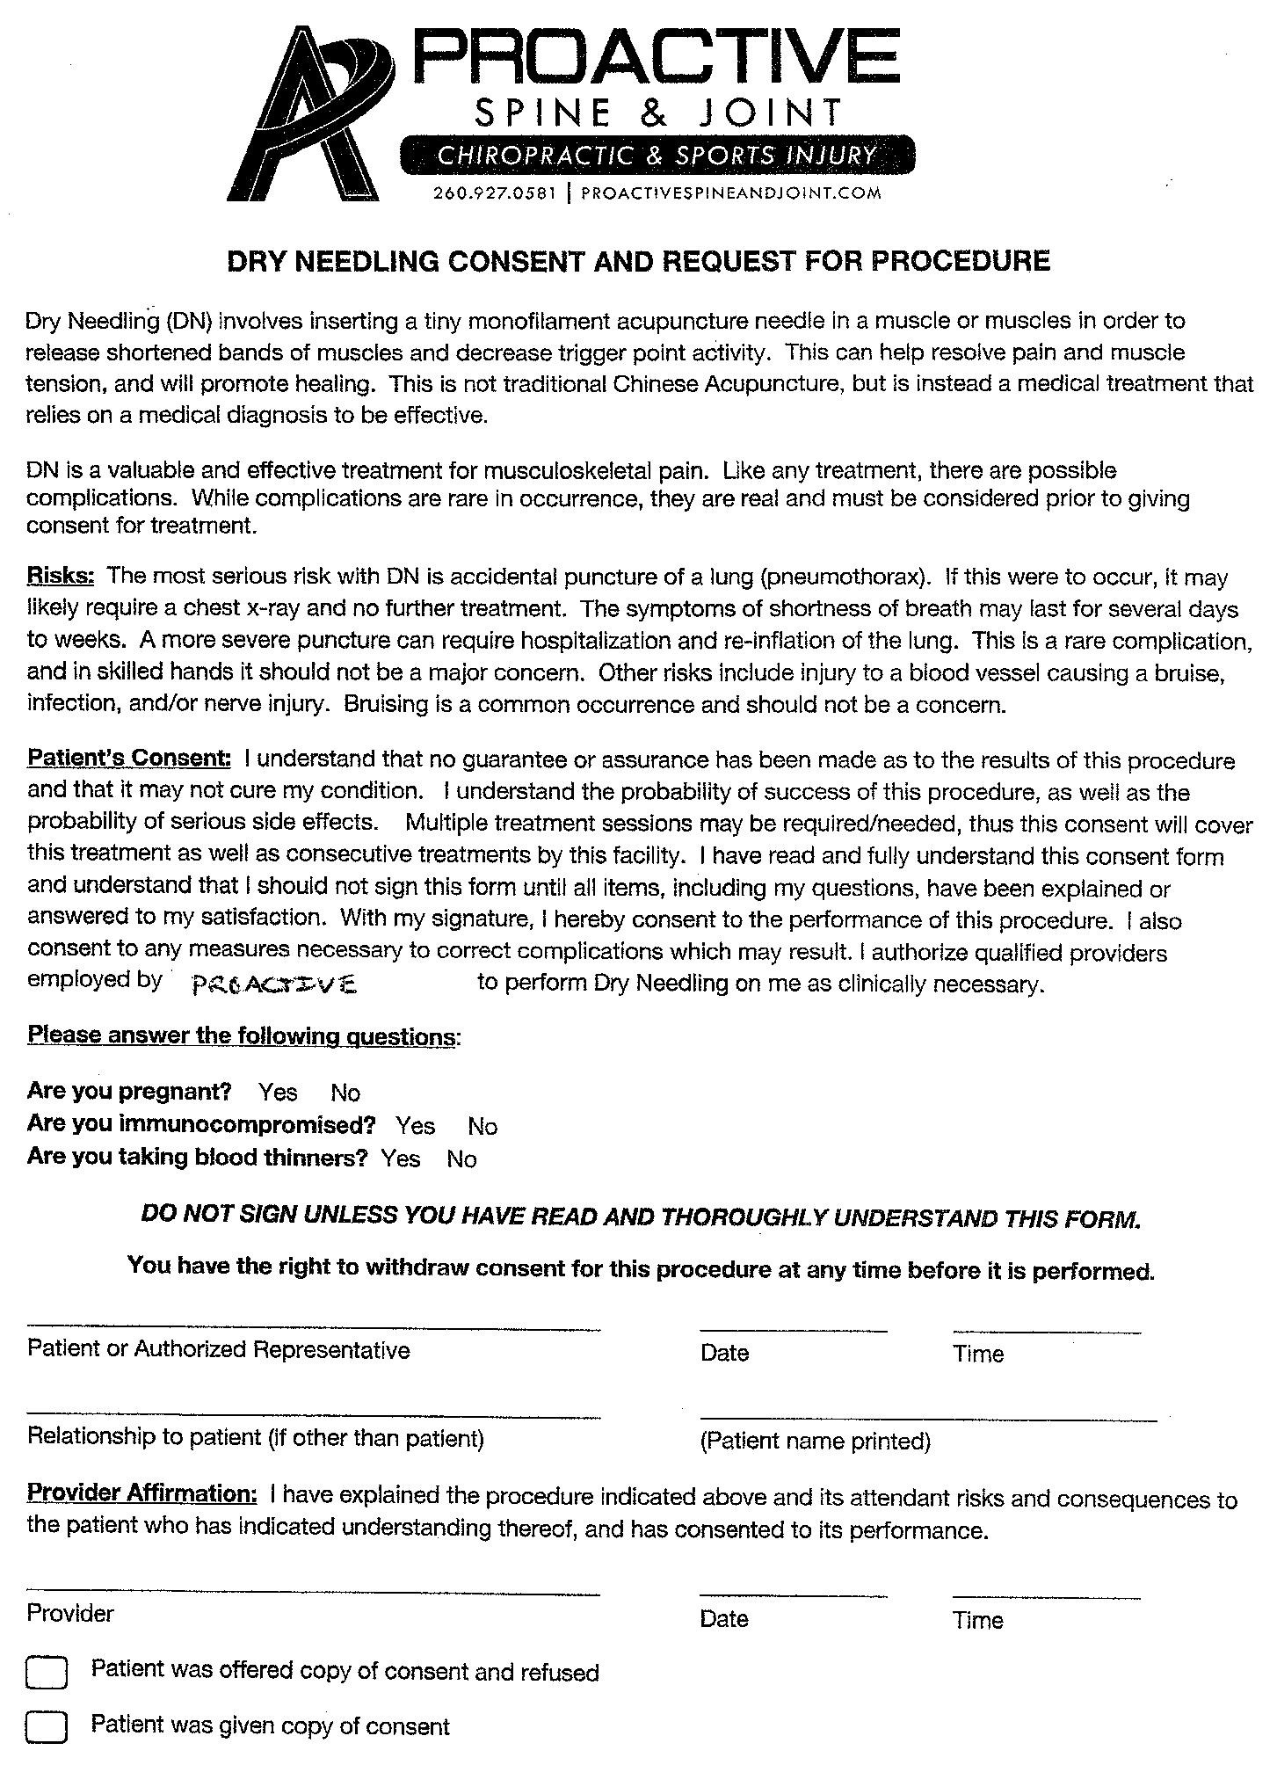

Missed Appointment Policy

Our goal is to provide quality chiropractic care in a timely manner. In order to do so, we have had to implement an appointment/cancellation policy. This policy enables us to better utilize available appointments for our patients in severe pain needing immediate care.
__________________________________________________________________________________________________
Cancellation of an Appointment:
In order to be respectful of the needs of other patients, please be courteous and call the office promptly if you are unable to attend an appointment. This time will be reallocated to someone who is in urgent need of treatment. If it is necessary to cancel your scheduled appointment, we require that you call at least 24 hours in advance. Calling early in the day is appreciated. Appointments are in high demand, and your early cancellation will give another person the possibility to have access to timely medical care.
How to Cancel Your Appointment:
To cancel appointments, please call 260-927-0581. If you do not reach the receptionist, you may leave a detailed message on the voice mail. If you would like to reschedule your appointment, please be sure to leave us your phone number and let us know the best time to return your call.
No-Show Policy:
A "no-show" is someone who misses an appointment without calling in advance to cancel. "No-shows" inconvenience those individuals who need access to care in a timely manner. A failure to show up at the time of a scheduled appointment will be recorded in the patient's chart as a "no-show".

Failure to call or show up to your appointment will result in a $25.00 charge.
We require a 24 hour notice of cancellation

*If you call ahead letting us know you are running late there will be no charge*

DO NOT SIGN UNLESS YOU HAVE READ AND THOROUGHLY UNDERSTAND THIS FORM.

You have the right to withdraw consent for this procedure at any time before it is performed.

Patient Signature:
Date:______________

Provider Affirmation: I have explained the procedure indicated above and its attendant risks and consequences to the patient who has indicated understanding thereof, and has consented to its performance.

Provider:_____________________________________________ DATE:_________________________

Patient was offered copy of consent and refused Patient was given copy of consent

